Comic themed class blog badges
Blue Beetle
Very responsible

Flash
Great powers of deduction
Green Arrow
Always hits the target

Green Lantern
Impressive strength of character
 | Phoenix  Amazing mental powers  Captain Marvel  The wisdom of Solomon | 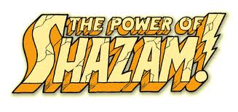
 | Spiderman  Great at making connections  Thor  Impressive in every way | 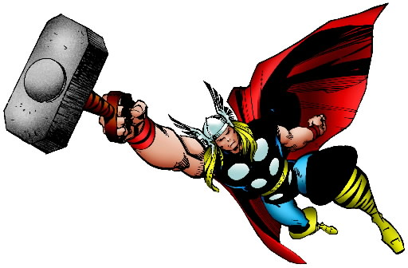
Wolverine
Sharp and incisive (writing)

