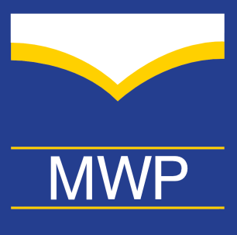
Organization
Morehead Writing Project
2018
General Receipt Date
Friendship Gift
Description
Morehead Writing Project
C/0 English Department
150 University Boulevard
Morehead State University
Morehead, KY 40351

Inquiries:
Kelli Besselman
kmbesselman@moreheadstate.edu
Phone 606-783-2426

Check number:
Amount per Friendship Gift: | $50
# of gifts:
Total included: | $
PAID

