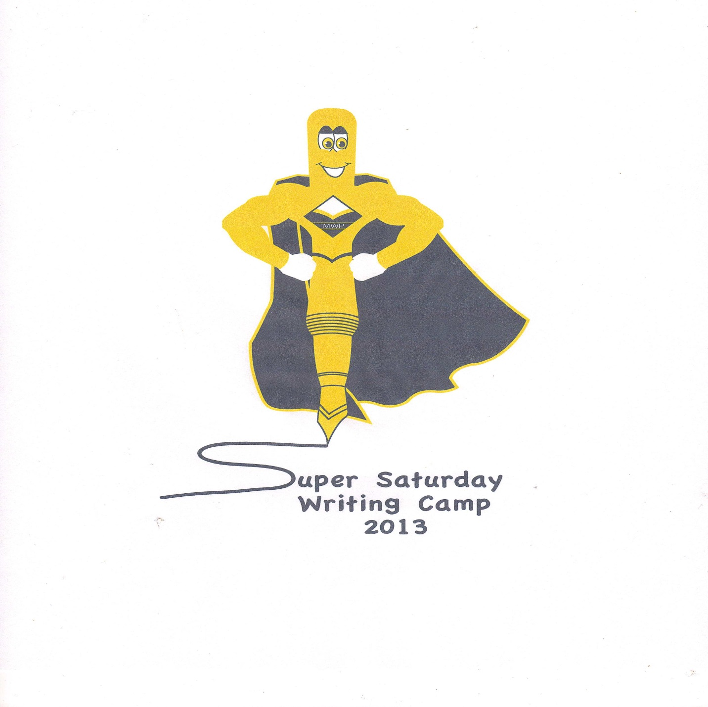**Writers’ Anthology**

Table of Contents

One Strike Angelida L. Stewart Page 2

Autumn Leaves Autumn Stark Page 5

Freedom Autumn Stark Page 6

The Contact Collin B. Tuerk Page 7

BFF Christina Oney Page 8

Zombie Invasion Eric Delapaz Page 10

Where I am From Erin Barker Page 11

The Sugar Fight Hadley Alderman Page 12

Where I’m From Hayley Krueger Page 13

Defeat of the Brownies Jacob Agee Page 14

The Walkabout Project Joseph Manley Page 15

The Walking Dead Joshua Ishmael Page 16

I’m From Lauren Elliott Page 19

The House Lauren Elliott Page 20

Best Friends Forever Maggie Qin Page 21

The Blank Wall McKenzie Stamper Page 24

Best Friends Miki Marksberry Page 25

Where I’m From Miki Marksberry Page 26

A ‘Full of Sugar’ Fight Morgan Deanna Hedges Page 27

Summer Days Rachel Hanshaw Page 28

Where I am From Rachel Hanshaw Page 29

The Wonderful Adventures of Mr. Piggle

-Wiggle-Ding-Dong Selah Bussell Page 30

Where I am From Selah Bussell Page 32

Where I’m From Zoe Callahan Page 33

One Strike

By: Angelida L. Stewart

It was a cold dark night. Thick fog wrapped around me. The wind seemed to whisper my name. My heartbeat was quick. I dropped the bundle of flowers that I was holding in front of the tombstone.

I turned around and started to leave. As I walked, my shoes made a nice sucking sound. Suddenly, I tripped over a mossy tree root that had risen up out of the ground. I fell into a deep hole.

I reached out, hoping to grab hold of another root. I was surprised when I did grab ahold of something. The thing held onto wasn’t a root, but a long metal pole. I slid safely down the pole until I was on solid ground.

“Where *am* I?” I wondered out loud to myself. I felt around on the walls until I found a door knob. I turned the knob and was surprised with a blast of light.

“A lantern!” I cried out. I picked up the lantern and looked around. I found a brand new battery for my lantern and a silver box. I slipped the battery into my pocket and opened the box. Inside was a beautiful silver sword with a long narrow blade. It looked just like my old sword, except this one was decorated with shiny and colorful gems.

“Hello,” said a cheerful voice. I turned around slowly; ready to slice any moving thing in half. I was shocked to see a little girl maybe around the age of eleven standing in the doorway.

“Sorry to scare you,” she said, smiling. “My name’s Maggie. Maggie Staton.” Swiftly, she skipped over beside me. “What’s yours?”

“Andrea. Andrea Dayridge. You can call me Andy.”

“Andy,” she said smiling. “What a beautiful name.”

“Thanks.” I said. I don’t think Andy is a pretty name at all.

“Andy,” Maggie said. “Since you have a sword, do you think you could maybe come and slay the dragon that always tortures my village?”

“Dragon?” I stopped. “What dragon?”

Maggie sighed and looked down at her feet. “Daggalore the third. Dag is a mean, nasty dragon that comes to the orphanage where I live. Dag’s so mean. He makes us orphans line up outside. Then he picks one out. Later on, he eats them.”

I couldn’t believe what I was hearing. I gulped.

“No joke?” I said.

Maggie just looked at me and said, “No joke.”

“Well then,” I said, as confident as I could be. “Let’s go slay us a dragon.”

Maggie smiled and showed me which way to go.

****************************************************

“Are we there yet?” I said tiredly, collapsing on the ground.

“Yes,” Maggie said, pointing. Up on a hill, surrounded with thorny vines, was a giant stone castle.

“Finally,” I said. I walked down the grassless hill and stopped at the vines. I held up my sword and cut a path so we could get to the castle.

“Andy?” Maggie said. I was searching for an entrance. When I looked up, she was standing by an open door.

We walked into the castle.

“Hey!” I turned to see a big ugly dragon, who I was guessing was Dag. I held up my sword and brought it down Dag’s head. Dead.

“That was easy,” I said.

Maggie and I lived happily ever after…after I adopted her!

THE END!

AUTUMN LEAVES

By: Autumn Stark

The colored leaves of the autumn trees,

Red, yellow, orange, and green.

The cool breeze blowing the leaves,

Dancing around the trees.

A family filled holiday season,

While my friends and me jumping around on piles of them,

They always brighten up the day and make everyone of them feel like a parade.

The autumn season is a time of, joy and happiness,

Fall is the best of all.

FREEDOM

By: Autumn Stark

The ones who served,

The ones who died,

The ones who suffered the ones who cried.

They are forever remembered,

And never alone,

Because every veteran deserves someone.

They fought in battles we can’t ignore,

Because they will stand and fight and say no more,

We may be tiny,

But we are strong,

We will hold our heads high and go along.

We are brave and smart,

And nothing can break us apart,

We are now a free, strong country

Thanks to the ones who served.

They are forever in our hearts,

And forever missed.

The Contact

By: Collin B. Tuerk

*There was A man named A.W. Logan some say he died of cancer others say it was A heart attack but let me tell you what really happened that night 1888. he was walking down A dark alley on the bad side of town . Another man was walking toward him they both stopped right beside each other the man said did you bring the stuff Logan said yes. He gave the man A black suit case. The man said I can’t let people know about this and A.W. Logan was never seen again. Logan’s contact the mutant brownie came to see what was wrong but when the mutant brownie got there he saw his contact lying down in the ally. That night the mutant brownie vowed to put the man to justice who did this. The mutant brownie dusted for finger prints at the crime scene. The mutant brownie found some on the body he analyzed them and it turns out his name was Etzio Lerinzo the mutant brownie got on his face book page ,but there was no information on there so he got out A phone book and looked up the address. When the mutant brownie got there he knocked on the door. A huge man opened it. The mutant brownie asked are you Etzio Lerenzo the man said yes in A very deep voice. The mutant brownie said your under arrest for murder of A.W. Logan Etzio said what are you talking about. The mutant brownie could tell that he was lying. Then Etzio punched the mutant brownie and climbed to the highest building the mutant brownie did the same. When they were both at the to Etzio was on the ledge and then jumped. The mutant brownies job was done, but what the mutant brownie didn’t know was there was A huge hay stack. So next time you see A hay stack make sure you better inspect it.*

BFF

By: Cristina Oney

Pierre Reef lived on a costal island in the east, he was hitting on some hot babes on the beach but that did not turn out so good. “Oh I know my feathers look like this but I am not that type of penguin!!! Oh I can never make friends I guess it is just you and me Bob. Hey Bob you think you can catch some fish for us? Water comes out of Bobs blow horn. Bob said:”Ok boy go catch some fish.

TWO HOUR LATER

“Ok so Bob did you catch some fish? Pierre said: “Yes he opened his mouth full of fish. “Good job so let’s eat! Bob did you meet any other whales? “No he said sadly” “Oh well, l am sure some day you will meet another whale.” They sat down next to the hot cracking fire roasting their fish. “Well thank you for the fish Bob, especially the squid it was delicious! “You are welcome Pierre! Well I think I should go to bed. Oh, and thanks for letting me sleep in your mouth tonight. No problem! Well good night!

SEVEN HOURS LATER

“Woof!” ”Um Bob what is that what said Bob open your eyes oh it appears to be a dog said Bob open up please ok I looked up the sun was yellow in the sky I looked down I saw a little shaggy brown dog. “Hi my name is Pieria the dog and you are my long lost brother we got separated at sea and I have been looking for you ever since. Oh you have a whale t Bob look over at the sea he saw a real live whale he leaped of joy well lets go meet dad this is so exiting come on!!!

ZOMIBE INVASION!

By: Eric Delapaz

One day John was walking by the cemetery and it was dark, heard a sound that was creepy, he said who is there ,he said then a hand came up from underground then he pulled out his gun and shout it, he saw a lot of hands come up!, he said it’s a zombie invasion , he said but there was zombie s behind hem, he tried to shout the zombies but he was almost out of ammo so he went to a building and other people was boarded up the doors, the people was waiting for hem and he saw a lot of snipers in the windows, almost all the windows and ammo, John saw lots of gun, he saw a mini gun and someone said ever body get to a sniper and almost everybody started shouting almost at once, its be 40 day they had to shout then no zombies came so the zombie invasion was over.

Where I am From

By: Erin Barker

I’m from laughter in the morning

From the sweet smell of flowers

And the smell of coffee

I’m from the Kentucky state with my family

I’m from the smell of trees when my mom wakes me up

I’m from the work in the garden

And my blue eyes gleaming in the beautiful sunlight

From my dad’s sweet smile when we play in the sunlight

I’m from the sweet smell of coffee when I wake up in the morning

And the time we spend planting trees and flowers

I’m from the cold snow on December 8th 2001

That’s where I’m fromC:\Program Files\Microsoft Office\MEDIA\CAGCAT10\j0281904.wmfC:\Users\MSU User\AppData\Local\Microsoft\Windows\Temporary Internet Files\Content.IE5\C8LYBT76\MC900445598[1].wmfC:\Users\MSU User\AppData\Local\Microsoft\Windows\Temporary Internet Files\Content.IE5\HFW122Z5\MC900434637[1].wmf

The Sugar Fight

By: Hadley Alderman

Mrs. Bradley sneaks stealthily through Sweet wood forest. She reaches into her quiver of candy cane arrows. As she prepares to hunt the sour patch candies who destroyed her village. They kidnapped her family, to lure her into a trap.

As Mrs. Bradley was aiming down she noticed something moving in the tree but luckily it was only her army of mint green peeps. Mrs. Muncie her sidekick, plants marshmallow bombs in the enemy’s fort. Mrs. Bradley shoots one of her candy cane arrows and misses.

Where I’m from

By: Hayley Krueger

I’m from my mom waking me up with the sweet smell of flap jacks and syrup being made I’m from a three bedrooms & two bathrooms. I’m from flap jacks for breakfast

Every morning & I have ten brothers and sisters I’m from my mamaw, papaw & my uncle last but not least my dad, how loves me. I’m from my mom in the kitchen cooking maple syrup mean wile me and my dad in the living room horse-playing laughing & joking,

And my mom saying “I will always be there for you.

DEFEAT OF THE BROWNIES

By: Jacob Agee

After Mrs. Otis cuts the mutant brownie into half the top half falls on her and turns her into a chocolate robot the peeps, Mrs. Little, robot Otis destroy the army of mutants and get there family back but they forgot about the snowball bombs and they all got blown up and away.

1,000,000 years later

And still today the cops look for the body parts to everyone.

The Walk About

Project

Biography By: Joseph Manley

First I went to The Old Town Cemetery and found out that it was established in 1870 by the Oxley family. I found out that 17 babies were buried there. A baby named Mary Nelson was killed coming home from the hospital in a car explosion. Then I went to Dr. Waynes house that is right by the campus. It also has 2 floors. He has ginko tree, a pine tree, and a dogwood tree in his front yard. He also has two windows in his atic.

Then I went to the Memorial Wall and it had a statue of an army man.

The first name on the wall is Carl Aagaard and the last name is Don Young. There is 27 Tompsons and 24 Tomas’s. The wall is made of marble.

The Walking Dead

By: Joshua Ishamel

At the graveyard today we were writing names of people who have passed away. But something was strange, there was something that pushed the ground up beneath men the teacher said I was crazy when I told her but I know what I felt and I’m not going crazy. As we were leaving I asked If I could stay and write more , Then she said I could but I have to be back before lunch, But when I went to set down there was a big hole where I had sat before. But I ignored that. I went to go in after a while but there was someone who was walking funny I went to go check it out … as usual then I asked the man if he needed help getting inside but when he turned around he was no typical old man he was a … walker! I knew something was not right. Then it chased me all the way to the Reds Forest, The scariest place in town. No one has come even near the Red Forest. When I looked behind me it wasn’t’ chasing me anymore what a relief. Then I found this old abandoned house after a little while I had already boarded up the windows then I found some guns in the back where the closet is. Then when I came back there must have been one –million zombies out there! Bang! Boom! Went the guns for 7 hours! The hole must not have been infected because it was over

The End

I’m From

By: Lauren Elliott

I’m from Maggie from Kroger and Mcbrayer I’m from Morehead

I’m from the strawberries, bananas, and grapes I’m from opening

Presents on Christmas and Christmas Eve and putting up a Christmas

tree with my dad, stepmom, and dog Maggie I am from going to church and celebrating Valentine’s day by giving presents from fun an exciting and I will do good in school I’m from Mount sterling hospital in 8/28/03

I’m from a big family that I love a lot an I’m from going to bed at 9:00 i’m from having fun and most of all I have a family that loves me

The House

By Lauren Elliott

There’s

14

Windows

For the

President

To look

Out

But what I

Know about is

Why he is

So lonely

I wonder if he

Has kids or

If he has a wife

Best Friends Forever! (B.F.Fs)

By: Maggie Qin

My father always told me that I had a twin that was a penguin, his name was Pierre Reef, I really want to meet my mom again and Pierre. I went to take a walk, immediately, all the boys turned to look at me. Am I really so pretty? I hurried and ran back to Polkaria’s house. Polkaria is just like me. She is missing her long lost twin too. She said his name is Bob.

Polkaria and I are best buddies; we took a walk together and looked at the shimmering sea. I remember when I was young, Mom’s last words to me was: “no matter where they are, we would still look at the same moon. I wonder where those dinosaurs took mom and Pierre.

Polkaria jumped into the water to catch fish for us, she came back with a mouth full of fish. “Oh Goodness Polkaria! That is a lot of fish. Thanks! Any luck finding Bob?” “No, and you are most welcome!” The two friends walked down the beach and talked about a lot of things. Finally, the two friends separated and went home……

“Wake up Pieria, there’s a penguin and a whale outside and there might be a chance they are Pierre and Bob. I ran to Polkaria’s door and told her about the news. We ran back to the shore where dad said the penguin and the whale were. “Hello, what is you guy’s names? We think you are our twins.” I said. “Our names are Pierre Reef and Bob Splash.” Pierre said. “You guys are our twins!” I exclaimed. “Are you guy’s names Pieria and Polkaria?” “Yes!” The two pairs of twins finally found each other!!!

The Blank Wall

McKenzie Stamper

Why is there a blank wall? Why there is a blank wall is if there was another war they would take the names of the lost and put it on the wall. But hopefully there are no more wars. The other walls had all kinds of names. If you don’t know what a war is it is a fight where you actually fight over land. Not boyfriends or girlfriends

Best Friends

By: Miki Marksberry

They might have good or bad days,

But they’re friends just the same,

They could either frown or smile,

But they’re friends just the same,

They could have parties in the attic or just stay by themselves,

But they’re friends just the same,

They could either smile or cry,

But they’re friends just the same,

But no matter what kind of friends they are,

They need you just the same,

To be a best friend means to try and care and laugh,

It doesn’t matter if they laugh or cry or almost give up,

They’re friends just the same.

Where I Am From

By: Miki Marksberry

I am from dogs barking,

From sunshine and smiles

I am from summer nights and backyard hammocks

I am from the tree in the yard, the rosebuds blooming

I am from the grace at Thanksgiving, and determination from Mom and Dad

I am from the laughter at Christmas and smiles at the park

From saying “Put that down” to “Remember your manners”

I am from eating a Popsicle on a hot day

I’m in Kentucky with uncles in Florida,

From cake and popsicles,

From laughter from Mom on Easter,

And the hard work from Dad,

I’m from the parties in the attic with my best friend

C:\Users\MSU User\AppData\Local\Microsoft\Windows\Temporary Internet Files\Content.IE5\7ZJAF9MY\MC900116000[1].wmf A “full of sugar” Fight C:\Users\MSU User\AppData\Local\Microsoft\Windows\Temporary Internet Files\Content.IE5\7ZJAF9MY\MC900116000[1].wmf

By: Morgan Deanna Hedges

Wrote on: April 27, 2013

@ Morehead State University

Mrs. Muncie sneaks stealthily through sweet wood Forest. She reaches into her quiver of candy cane arrows, as she prepares to hunt the Mutant Brownies and the chocolate bunnies that destroyed her village.

They kidnapped her family, to lure her into a trap. As she was aiming down her sight she noticed something moving in the tree, but it was only her backup army of mint green peeps.

C:\Users\MSU User\AppData\Local\Microsoft\Windows\Temporary Internet Files\Content.IE5\7ZJAF9MY\MP900442446[1].jpg Mrs. Bradley, her sidekick, plants marshmallow bombs on the economy fort. Mrs. Muncie shoots one of her candy cane arrows and misses her target. Without warning, the peeps launch sugar rocks at the sour patch kids that absorb them. They only make them stronger and that’s it. Mrs. Bradley cuts the chocolate bunnies in half with to decrease, that was a good thing

 Then as Mrs. Muncie was trying to defeat the mutant brownies, her army of peeps came and started shooting the sour patch kids with their jelly bean gun full of jelly beans. After the first was down the peeps were out of energy and jelly beans so, Mrs. Muncie was on her own now. So Mrs. Muncie had to do all the work herself. As she was chasing the last mutant brownie it ran over the marshmallow bomb and then the bomb exploded and the last sour patch kid died.

Then, Mrs. Muncie had saw Mrs. Bradley so she ran over to her and Mrs. Bradley said that she couldn’t find the rest of the chocolate bunnies but she did fined 102 of the 110 chocolate bunnies that people said there were. So Mrs. Muncie and Mrs. Bradley searched and searched for hours and couldn’t find the last eight bunnies. So they went back to their village and there to find were the last eight chocolate bunnies with her family. Then the chocolate bunny left and were never seen again. But everyone lived happily ever after.

Summer days

By: Rachel Hanshaw

Summer days

Just oh-so sweet

Summer days

Just waiting for you to greet

Tickling sand underneath your toes

The redness goes out of that cold winter nose

Although it seems short

Memories are made

Sometimes you have some that you can’t even sort

That’s just part of those summer days.

**Where I am From**

**By: Rachel Hanshaw**

**I am from books**

**With their soft papers**

**I am from the nooks**

**That hid me from the capers**

**I am from our pond**

**With the fish swimming around**

**I am from the leaves**

**With their sweet and billowing sound**

**I am from the early morn**

**With my brother’s voice**

**Sounding like a foghorn**

**I am from strong smells**

**Good AND bad**

**From the odor of my room**

**Making my mother mad**

**It depends on how you look at it**

**Your way of life is fine**

**It really depends on the person’s life**

**But I definitely like mine**

The wonderful adventures of Mr. Piggle-Wiggle-ding-dong

By: Selah Bussell

It was a wonderful day in Malware-Ville when Mr. P.W.D.D. was walking down the street. He came to the end of the street and decided “I want to go to the park” So Mr. P.W.D.D. went to the park. He saw mothers pushing their babies in strollers. He saw birds and all sorts of wildlife. Then suddenly right out of the sky fell a ball of fire. As soon as the ball hit the ground, the fire ceased and the ball cracked open. Out fell a note that said…

Dear Mr. P.W.D.D.,

If you ever wish to see your family again you will do as I say. In order to receive them back you must go to Amiro and kill a lion and bring me his head. I am in Augamaroo.Call 729-047-264.

This horrified Mr. P.W.D.D. He is in fact a vetranarien and he would never kill an animal. But he would to get his family back. So he went to Amiro to get the lions head. While he was on the plane to africa he asked himself this question, “Why does he want the lions head?” He thought and thought untill he fell into a silent sleep. He deamnt about his family. He missed them so much. Finally he got to Amiro. He bought a jeep to ride across the prarie. He rode for a really long time untill he finally saw something scampering across the prarie. As he got closer he relized that it was a lion. The lion fell to the ground. Mr. P.W.D.D. halled the lion on the back of his new jeep. Then he turned his jeep around and drove of twards the town. He drove for an hour and then he finally pulled into the town. He got out of the jeep and took a long look at the lion. Finally he found a pan and filled it with water. He put it in front of the lion. After awhile he decided “I guess he’s dead.” So he found a big box and stuffed the lion in. He hated to do it but he did.Then he got a ticket for an air plane ride to Augamaroo. After he got there he found a payfone and called the number.As soon as he got to where his family was being held captive he gve the lion to the man. He got his family back and he was back in MalwaresVille.

In Augamaroo the man who took Mr. P.W.D.D.’s family was just then opening the box. When he did out jumped the lion and he ate the man. As it turned out the lion was just asleep.

Where I am From

By: Selah Bussell

I am from the swing on the old oak tree, where I laugh all day.

I am from the crowing of roosters in the morning.

I am from the sweet taste of freshly picked strawberries in the hot summer, as they leave a sweet taste on my tongue.

I am from the hard work in the garden, where the veggies grow.

I am from where my sisters and I play and fish on the creek bed and we play all day until mamma calls us to home.

I am from the hard homework as I do it on the front porch when the sun goes down.

I am from my family’s history and that’s what I love.



*Where I’m From*

By:Zoe Callahan 04-27-13

I am from the country side,

From running and playing in my back yard

Amos my dog following behind me,

My mom in the evening doing house work really ignores he.

I know I am the princess in my palace of course,

But I hate it when I am locked in my dungeon.

I am from the old blackberry bushes,

From lettuce to onions and spinach

I am part Indian Irish and German,

But of course American.

I open presents on Christmas Eve and on

Christmas sometimes the day after.

I open on Easter my favorite holiday of all,

The sweetest of candy the candy of all.

I am from my Poppy’s weird cooking my

Mamaw’s new dog.

From my loving family and awesome

Dogs and that is where I’m from.